1) quicksort([X|Xs],Ys) :-

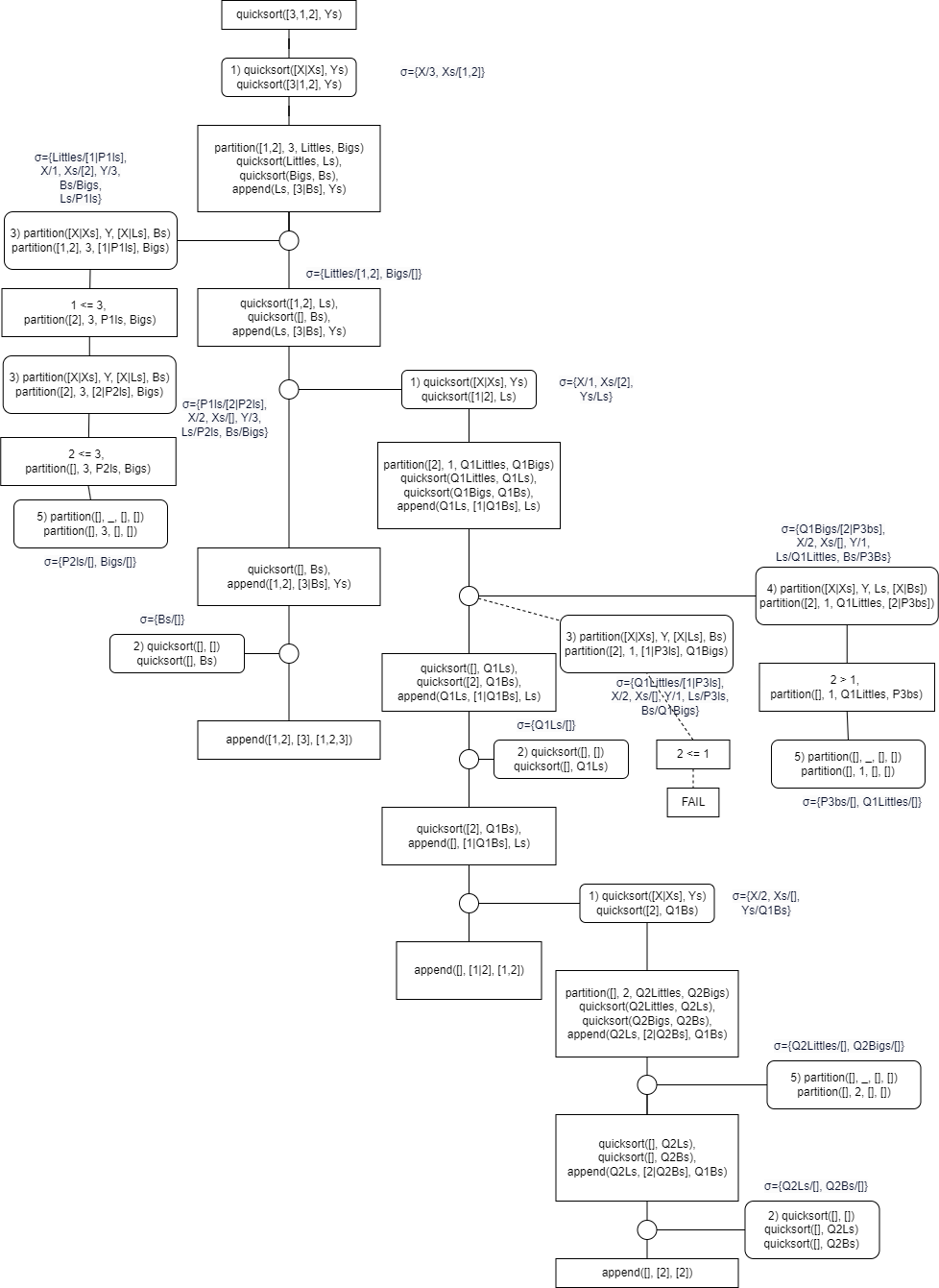

  partition(Xs,X,Littles,Bigs),

  quicksort(Littles,Ls),

  quicksort(Bigs,Bs),

  append(Ls,[X|Bs],Ys).

2) quicksort([],[]).

3) partition([X|Xs],Y,[X|Ls],Bs) :-

  X =< Y, partition(Xs,Y,Ls,Bs).

4) partition([X|Xs],Y,Ls,[X|Bs]) :-

  X >  Y, partition(Xs,Y,Ls,Bs).

5) partition([],_,[],[]).